How to install Office 2024 LTSC Standalone

- Acquire a copy of Office 2024 folder, it can be found at the following locations:
- \\CAHNRS-Files\Shares\CIT.General
- \\cit-distribute\install
- All that should be contained in the folder is two files, the setup.exe and the 2024.xml file
- Copy the Folder to the root of the C: drive of the machine you would like to install on.
- Open a command prompt as Administrator
- Type the command cd c:\office 2024 and hit enter
- Then type the command setup /configure 2024.xml and hit Enter
- If you receive an error message this should appear within 5 seconds, if you get no error you should not see a flashing cursor and the system should be install Office 2024 in the background.
- Once the cursor returns to a flashing cursor, you can type Exit.
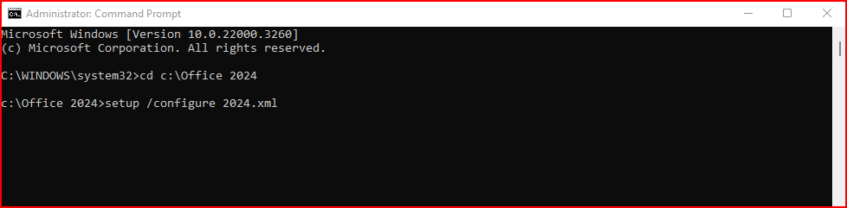
- Then verify that Office 2024 is installed and activated by opening Word, and then clicking on File, Account, and checking the status.

