Activating ESU with PDQ Deploy

- Navigate to your VM that has PDQ Deploy and PDQ Inventory installed on it and open PDQ Deploy.
- Look Under Eric’s Packages and you will find ESU Deployment, see image below:
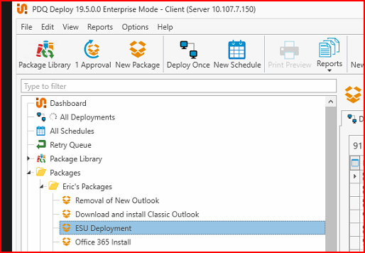
- Right-click on ESU Deployment and click on Deploy Once, a new windows will pop-up that looks like the one below:
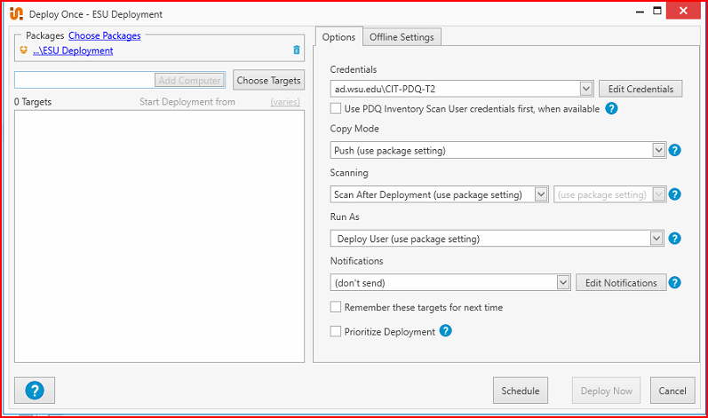
- Type the name of the computer you want to deploy to and hit Add Computer:
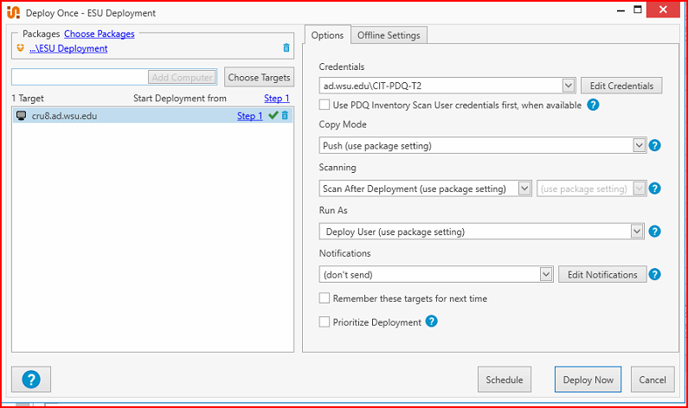
- Hit Deploy Now
- You will now either get an error, and you can click on the log and find out if there was a specific error, or the computer might not be able to be pinged.
This typically means that we are going to have to schedule a remote session for this computer. Example below:
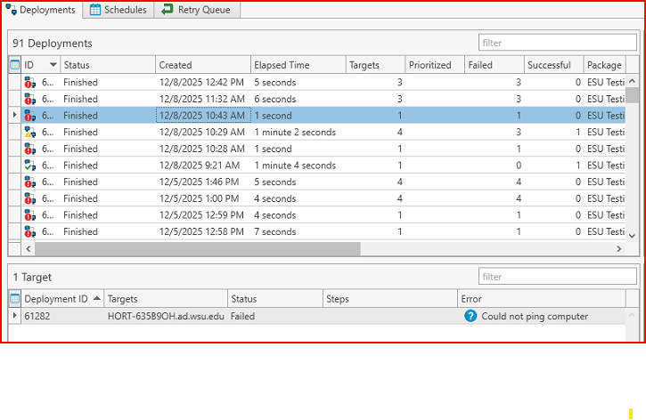
- Or you will get a Successful response and the system is good to go. I will include an example along with a copy of the log file when it’s successful:
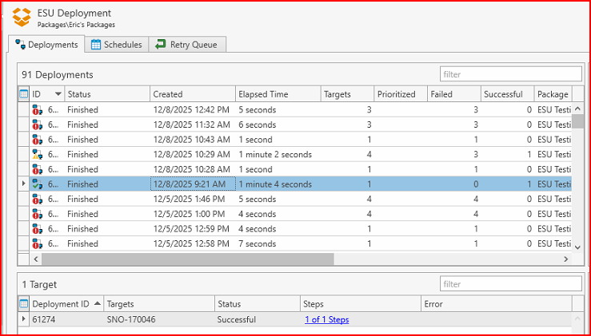

2025-12-08 09:22:21 [INFO] Installing ESU MAK...
2025-12-08 09:22:26 [INFO] ESU MAK installed successfully.
2025-12-08 09:22:26 [INFO] Activating ESU MAK for Year 1...
2025-12-08 09:22:31 [INFO] ESU MAK successfully activated for Year 1.

