When remote desktop has been disabled by group policy The Remote Desktop Settings will show this
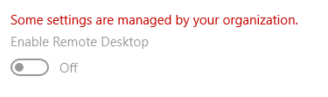

These are the steps to fix it:

Click the  button and type gpedit and click on 

In the window that opens up click on
Then click double click on
Then double click on
Then double click on
Then double click on

Then double click on

In the window that opens up change Disabled to either Enabled or Not Configured:

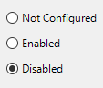

Then Click  and then click 

If you choose enabled the Remote Desktop Settings will show that remote desktop is enabled and can’t be switched off:


If you choose not configured Remote Desktop Settings will show this:


Choose which option will be best for the user.

