You can manage your new Team through the web interface at https://mydrive.cahnrs.wsu.edu/
Once you are logged in, you will see an icon at the top left of the screen called Workspace.
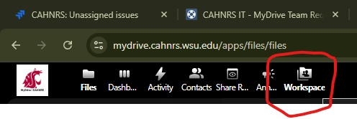
This will take you to the screen to add new members. Select the Team you want to edit and tip the arrow down to view the two types of user groups.
WM = Workspace Managers (Edit Access)
U = General User (Read Access)
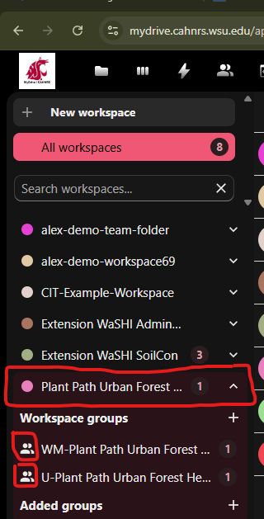

Select the group that you want to add the users to (Edit (WM) or Read (U)) and click the + button in the upper right corner.
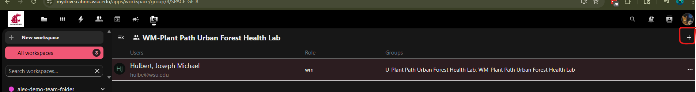
Start typing the email address of the users that you want to add to the Team. Once you find them, click the Add button. If you have several users, you can also import a .csv file.

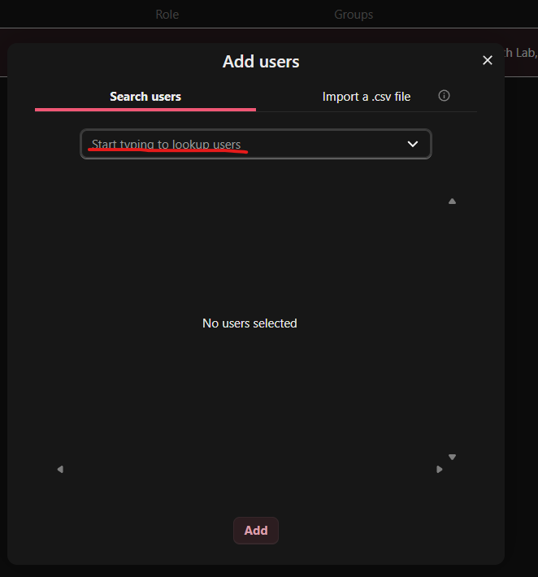
You can also edit users by clicking on the three dots to the right of their name and change permissions or remove them completely.
