Open File Explorer
Navigate to “This PC”
Click on the three dots in the top toolbar and select “Map a Network Drive”
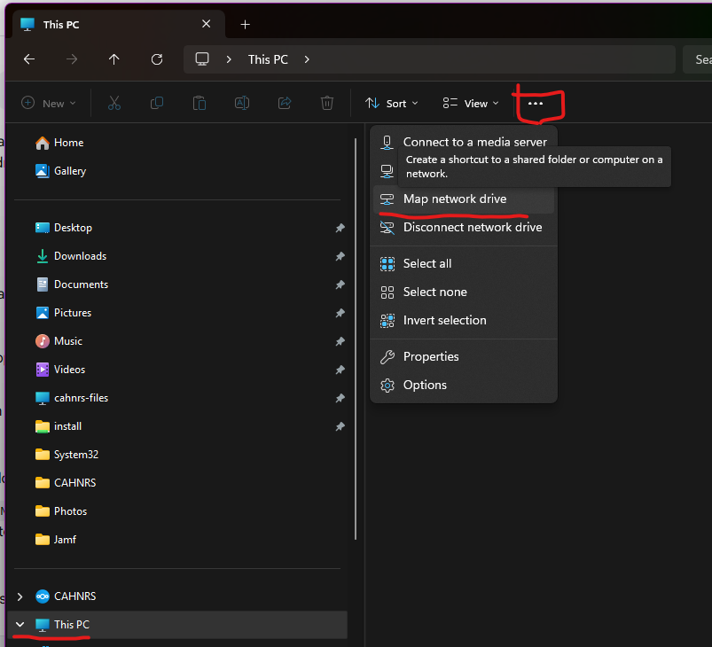
Select any available drive letter
Type the server path of the shared folder. The file path will be the following:
\\cahnrs-files\nameofsharefolder
You can choose browse after enter \\cahnrs-files\ to get a list of shared folders
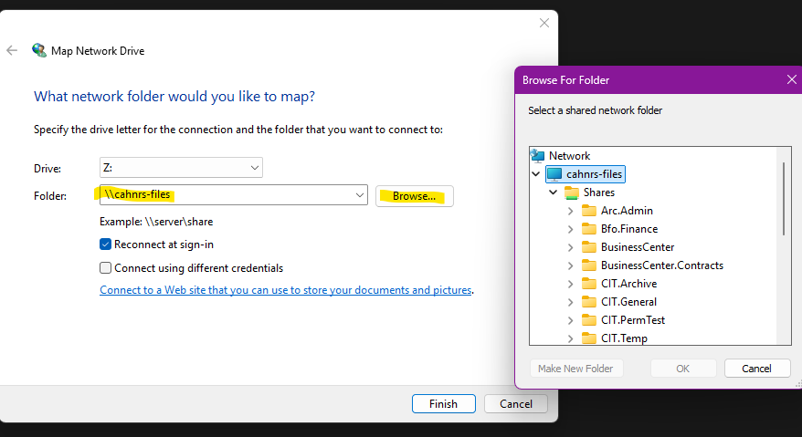
Choose your shared folder and click OK.
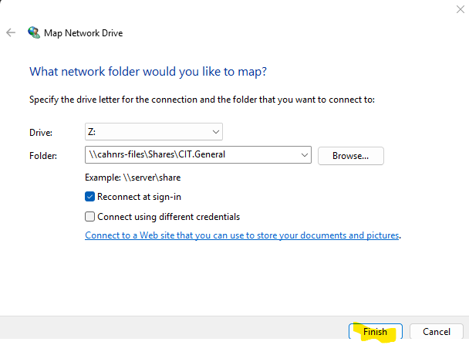
Click finish.

