Create a Donation in TouchNet
Log in to TouchNet – Expand your store settings and choose Products.
Click Add to create a new product
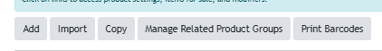
Type the name of your product, a description and under product type choose Donation
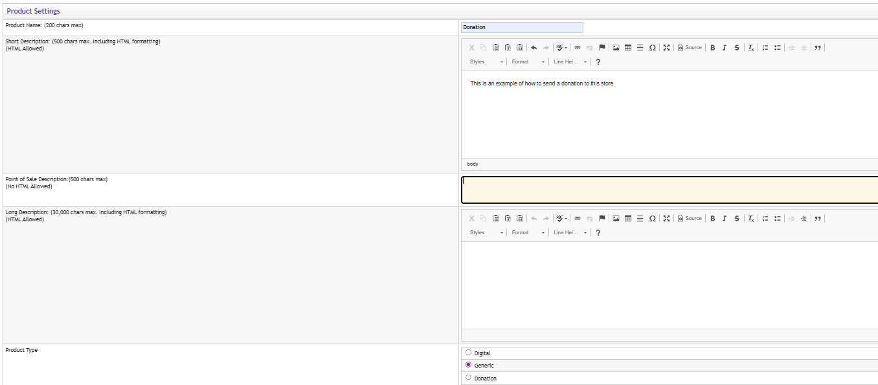
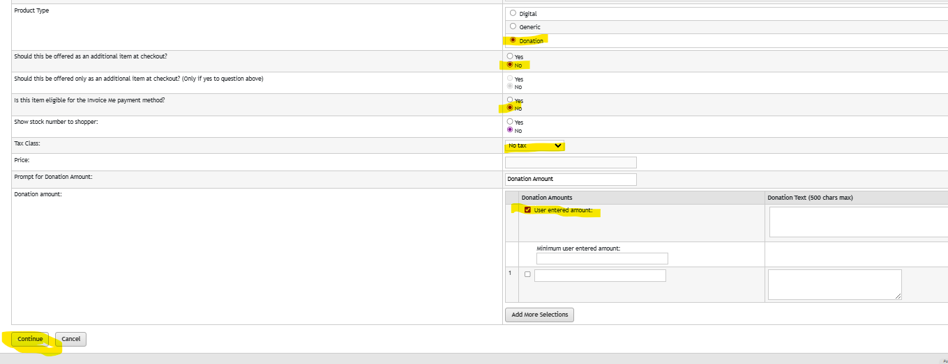
Decide if you want this to be an additional item at checkout (or exclusively available at checkout), whether it is taxable, and if the “Invoice Me” option is available for this item. Be sure to check “User entered Amount”. You can even set a minimum donation amount (not required). Click Continue.
Choose your Shipping class (None), select your Accounting Code, or choose an override accounting code. Determine if this requires special authorization, then click continue.
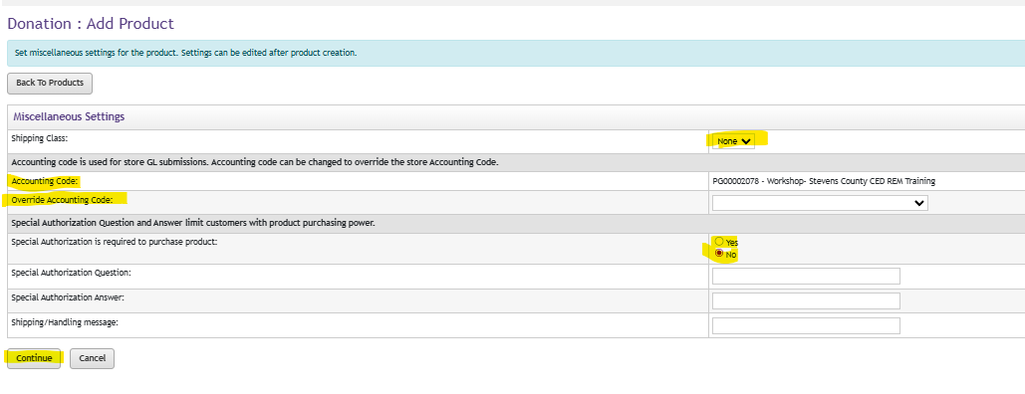
You can add a product image at this time if needed.
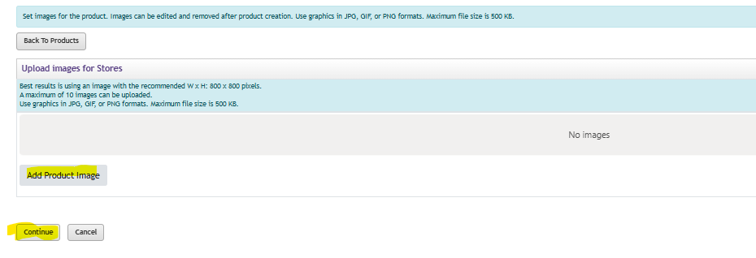
Add any options (this is usually no). Click Continue
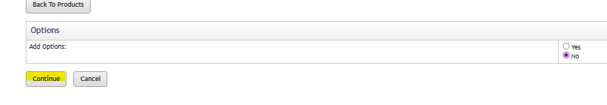
Assign your stock number/product name
Decide if there will be a limit to the number of donations allowed, and whether you want to track inventory on this. Choose Automatic Fulfillment so that the charge goes through when the customer places the order and set any email notifications you would like for this donation order. Click Continue.
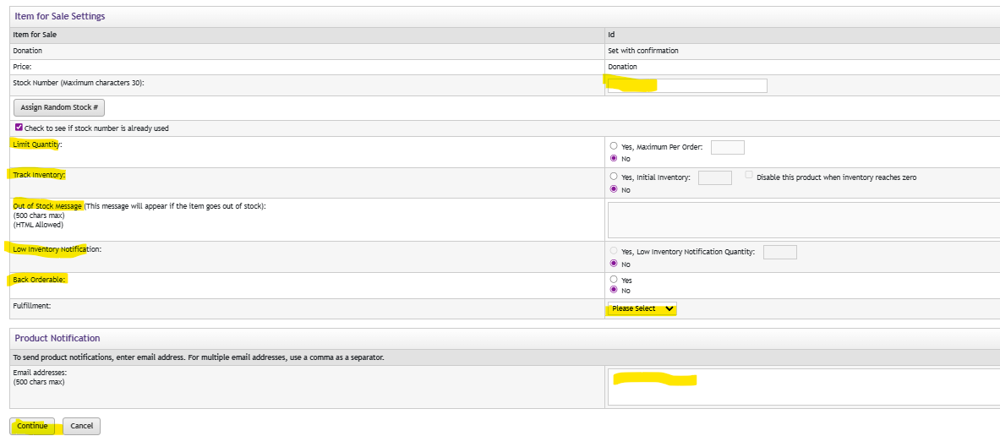
Set the product availability (Online Storefront and POS) and confirm.
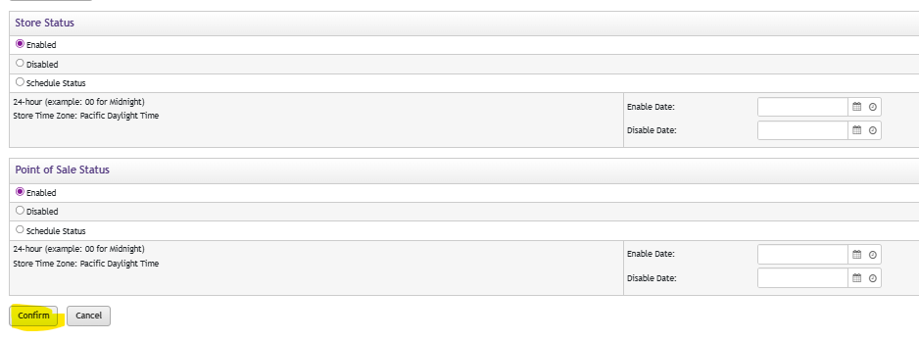
Choose where you want this displayed (Store Home Page, Category, Etc). Click Continue
