How to create Promotions in TouchNet
You can find the promotion settings under Store Settings.
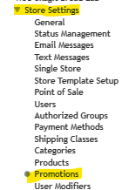
There are four different types of promotion options available.
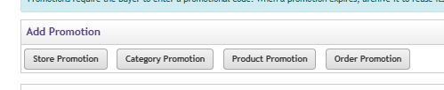
For this example, I am creating a product promotion that will reduce the cost of the item by 10%
Click on Product Promotion
Enter your promo code (what you want the actual promo code the customer will use)
Enter the name of your promotion
You can either choose a percentage or a dollar amount for your promotion.
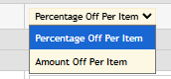
You can set the dates that the promotion is active.
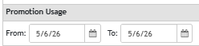
You can also restrict the number of times or promo codes a customer can use.
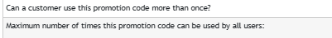
Next, select the products that will be allowed to use this promo code.
Create the promotion.

