How to delete a Product
Find the product listed under the store.
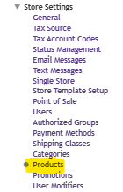
Click on the gear icon and choose Delete Product
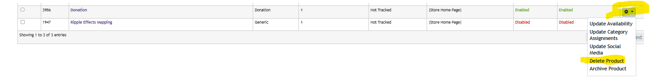
Confirm deletion.
