How to log in to TouchNet as a store administrator
TouchNet URL: https://secure.touchnet.net:443/central
To access the stores you manage, click on Applications – Marketplace
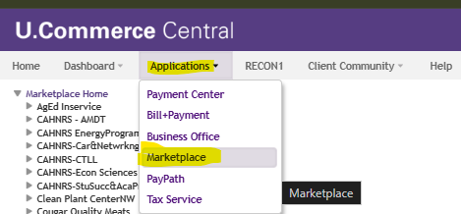
The stores you have access to will be listed on the left-hand side menu. To review the different store settings, tip down the arrows to get the full list of store options.
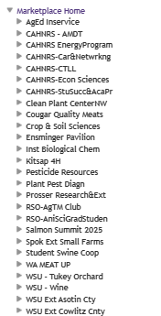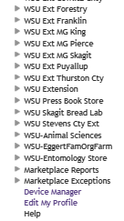

Here’s a fully expanded list of store settings.
