How to set store refund policy
Go to Store Settings- Store Template Setup
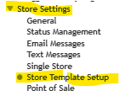
Click on Store Footer
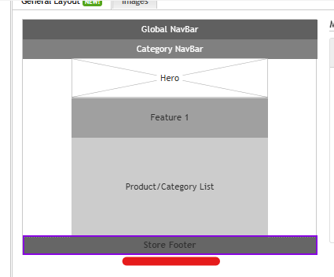
Tip down the arrow under Links.
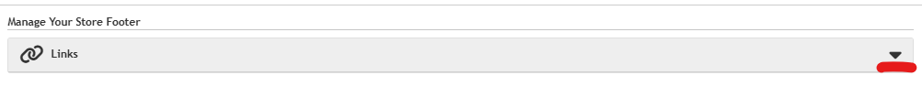
Expand the section for Refund Policy
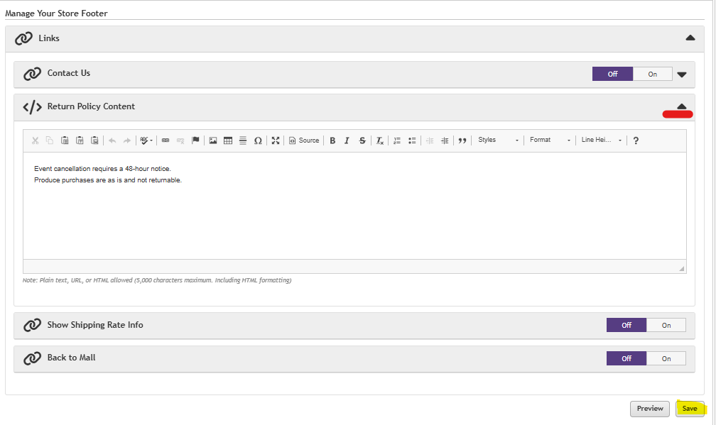
Enter your text and be sure to Save the changes

