How to set Store Status
Log in to TouchNet – Go to Store Settings – Status Management
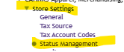
Enabled- Store is live and ready to go
Disabled- Store is offline
Preview- Allows you to view the store and test the checkout process without the store going live for everyone.
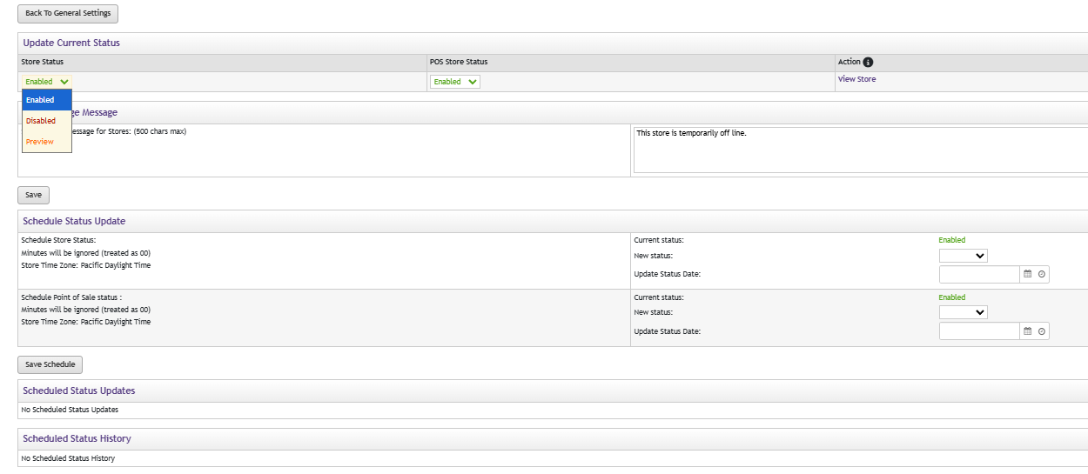
You can also set up a schedule for when the store is active and when it is offline.

