Processing Refunds
- Login to the TouchNet Production Site:
  - https://secure.touchnet.net/central
- Only users with the role of Fulfiller with Refund Cancel rights can process refunds online.
  - The store manager assigns roles within the store’s User settings
- Navigate to your Store in Marketplace and under the Store is a menu selection Refunds:
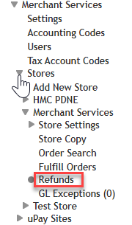
- Once you have found the single order you wish to refund and select Refund from the Action column
- On the next page you will find the refund page - you can refund a partial or full amount per product. Shipping may or may not be refunded in a field below, and you have the ability to attach a comment to the refund as a Refund Reason.
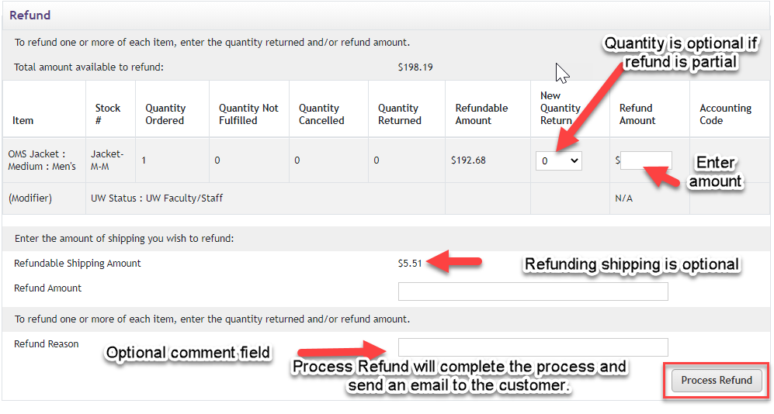
- The refund amount field only appears if partial refunding has been enabled
  - Setting “allow partial refunds” option to yes on the store general settings page

