It is recommended to create the categories and subcategories before creating the products. This allows you to assign the categories as you create the products instead of having to go back after the products are created and assign them to a category.

Navigate to the Products section of your TouchNet store and click the “Add” button to create a new product
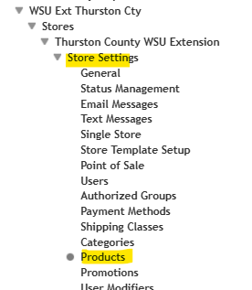
Enter a product name, short description, and long description.
Choose your product type (Digital, Generic, Donation)
Enter the price
Click continue
Decide your Shipping Class
Choose whether it is taxable or not
Select your Accounting Code (or choose an alternate override accounting code)
Click continue
If you want to add a product image, you can add it on the next screen
Click continue
You can Add Options or skip this section (this is great for choosing clothing sizes or colors)
Click continue
Create the stock number or product ID. This can be assigned randomly, or you can type what you want for the stock number
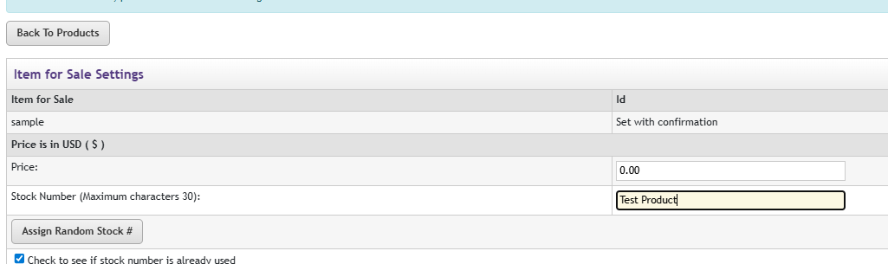
On this screen, you can also set your inventory quantity and set up a low inventory notification.
Under Fulfillment, choose automatically if you want the customer charged right away or manually if you will charge the customer at a later time.
Under Product Notification, enter the email address(es) where you want the order notification sent.
Click continue
Set the Store and Point of Sale Status – you can enable this at any time
Click Confirm to finish setting up the product
You will now be asked where in the store the product should live. If you have created categories, you can specify which category to save the product under. If you haven’t created categories yet, this can be edited later.
Click Continue
You can go back to Products, and your new item will be listed. If you need to add modifier data, you can do it from this section.
