TouchNet Categories and Subcategories
It is recommended to create the categories and subcategories before creating the products. This allows you to assign the categories as you create the products instead of having to go back after the products are created and assign them to a category.
Each store can have separate categories to better organize its products/events.
For example: A store sells tickets for an event registration, sells products (t-shirts, food), and accepts donations. You can have a breakdown of these three different item types, so it is easier to find what you are looking for.
Categories
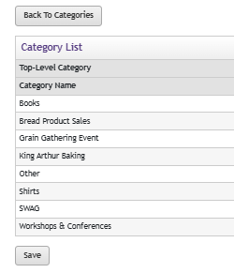
Products listed under different Categories
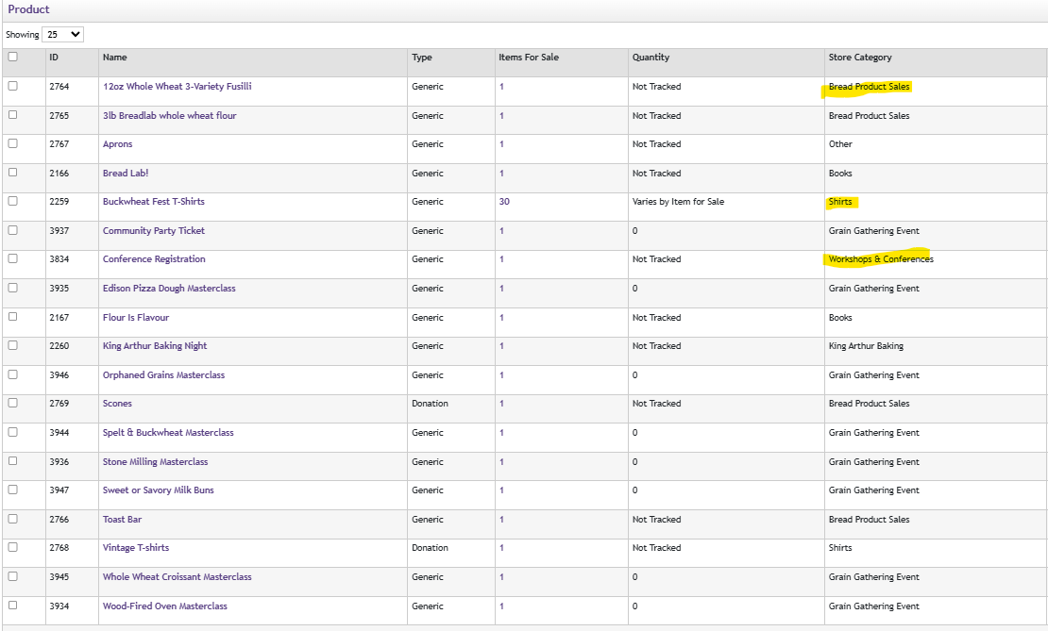
How to Create a Category
In TouchNet expand the menu for your store and choose Categories
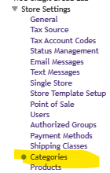
Add Top Level Category
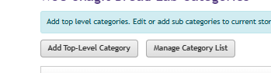
Type the name of your category and decide which layout you want to use.
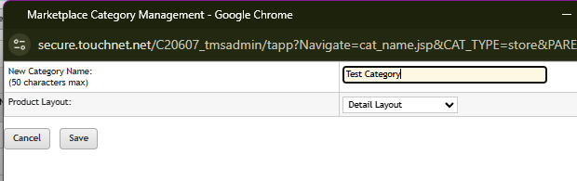
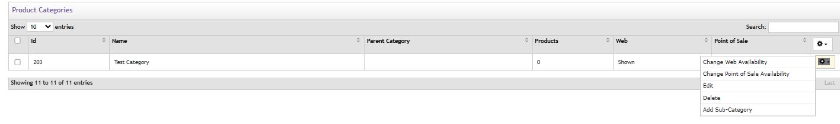
You can manage your category through the gear icon under Product Categories (this includes adding subcategories).
Once the category is created, you can edit the information to include images and add text to the category description. This is also where the QR code is stored for that category.
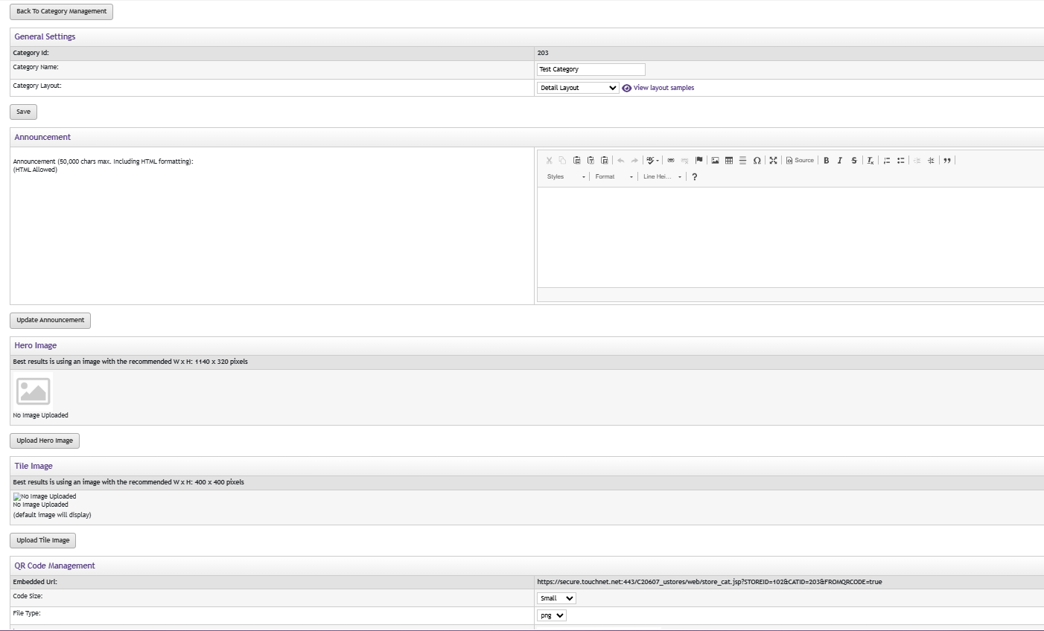
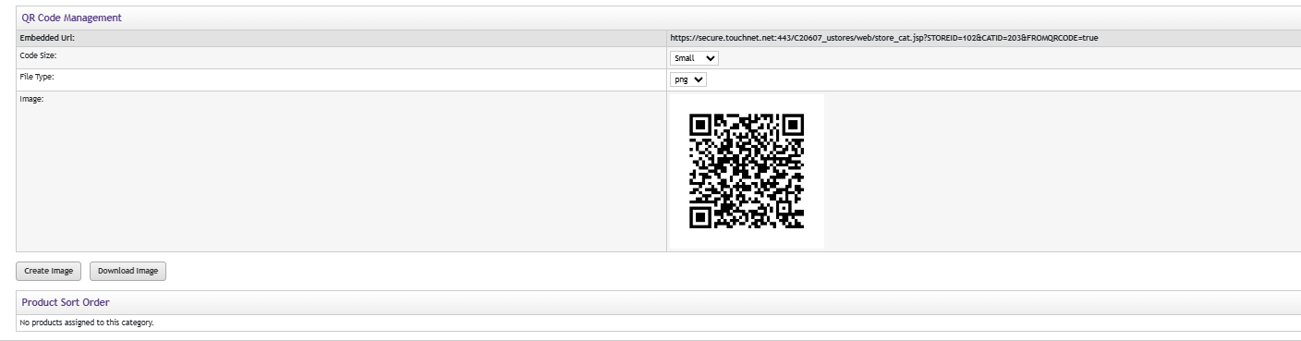
Change Product Categories
You have an existing product that needs to be added to a category. Go into your list of products and find the one that needs to be added to a category. Click on the product and scroll down to Category Settings
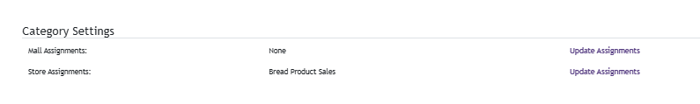
Mall Assignment needs to stay on the Pullman “Mall,” so don’t change that option. You want to edit the Store Assignments by clicking on Update Assignments
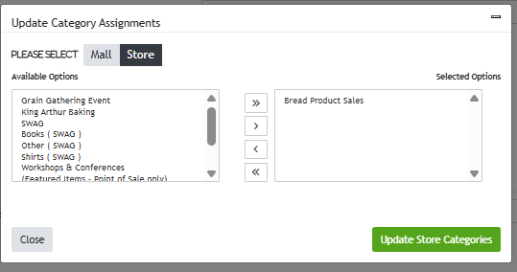
On the left are all the products available, and on the right is the category that they fall under. To edit the product categories, you can use the arrow to move items to the different categories available. Be sure to save your changes by clicking Update Store Categories.

