TouchNet Modifiers
Modifiers are great for collecting data from the customer. You can set modifiers on individual products, or you can set modifiers for the entire store.
There are eight different modifiers.
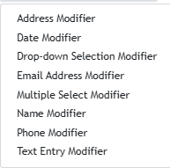
You can make them required or optional; you can hide them from the confirmation email or have them displayed.
You can also use a modifier field to do a price adjustment if needed.
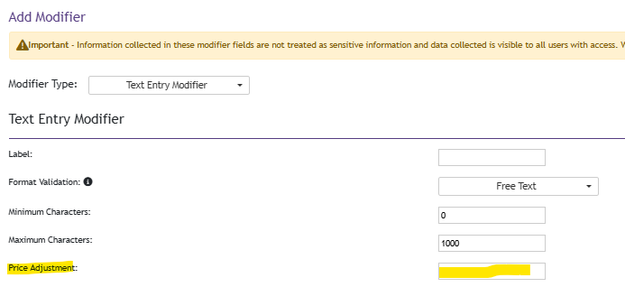
There is also an option to set it static or dynamic. If a customer orders two of something and the modifier is set to dynamic, the customer will have to enter the modifier data twice. For example, a customer buys two tickets for an event. The product modifier asks for their name. Since the customer ordered two tickets, they would have to enter the names of both people.
