Preparing for Your New Point of Sale Devices





In order to take advantage of your new ingenico Move 5000 Devices, you must update POSC software on each computer with which the Move 5000 will be utilized in taking card payments.

The supported POSC version for the Move 5000 will be 1.13.2 or greater

Information on installing/upgrading, and downloading the version of POSC needed is located within the TouchNet Client Community

If utilizing the Validated Point to Point Encryption (VP2PE) via our partnership with BlueFin, you must also complete Steps 2 and 3.





NOTE: When you receive your device in the mail, it will not work until the following steps are taken.
NOTE: You must check in your device as soon as you receive it, but keep it in the tamper bag until you are ready to begin using it.
- On your home screen of the P2PE Device Portal, there will be a notification that there is an open shipment
- Navigate to the “Shipments” tab
- Click on the view button on the left side of the shipment you would like to receive
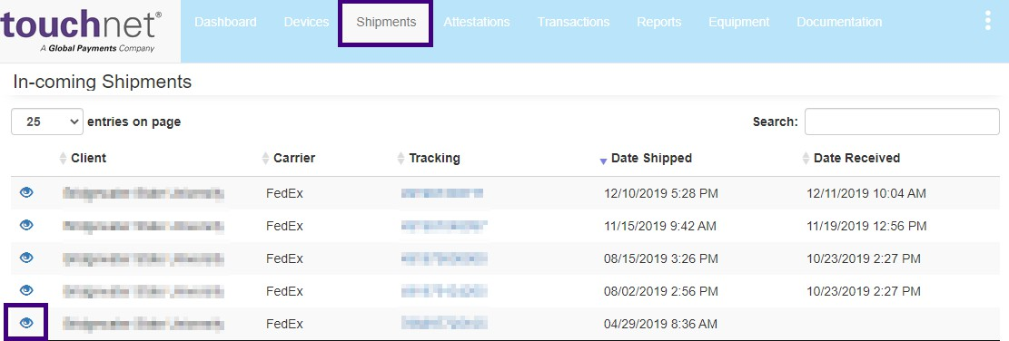

- Click on the “Receive” button next to the device
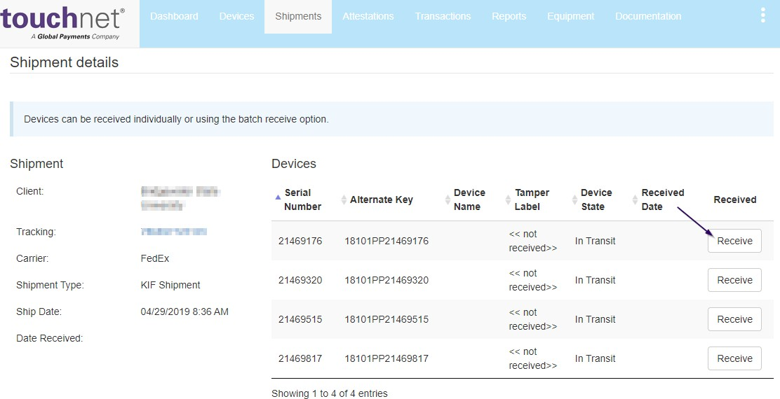

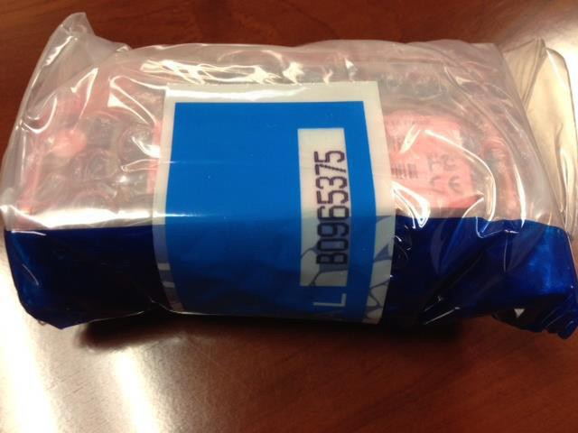
- Open the box but do not open the tamper bag. Your P2PE hardware will be wrapped in a tamper evident bag with a numbered tamper seal on the closure. You will need information from both the hardware unit and tamper seal. (Do not remove hardware from the tamper evident bag before you are ready to complete the receiving and inspection steps. Do not throw away the tamper evident bag and tamper seals.)

- Look through the bag and find the serial number and tamper label from the outside of the bag, enter them here and click “OK.”
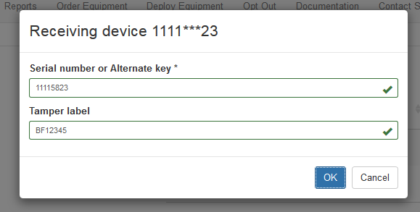

Once complete, the device state will change from “InTransit” to Stored. You MUST complete this step for each device received.
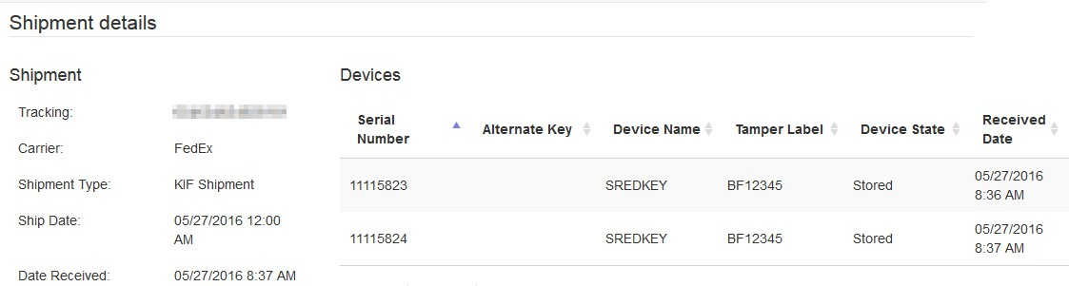



- Navigate to the “Devices” tab
- Locate the device that you would like to activate and click on the pencil icon on the left
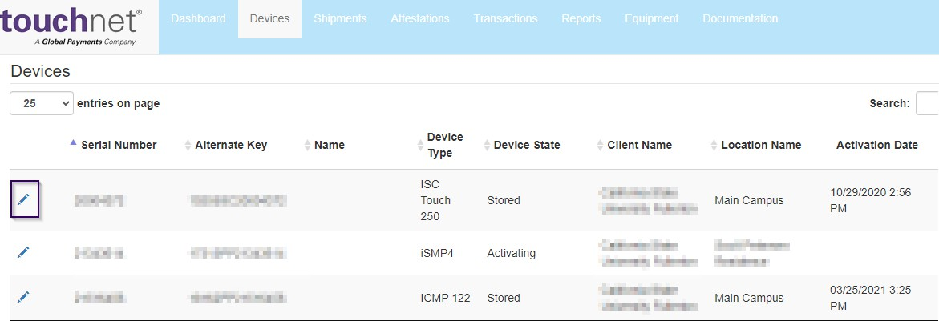
- Update the Device State to ‘Activating’ and Save
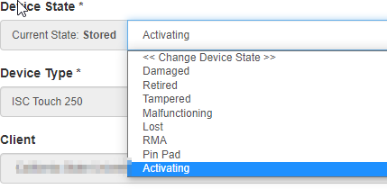
- Your Device is now ready to begin processing cards.

- For your iCMP and/or iSC250 devices, once new devices are in place you should update the status to Retired and store in a safe location. This will keep the devices from unauthorized utilization.
