How to use Make Me Admin
Find the search box on the computer desktop and search for “Make Me Admin”. Once the application loads, click on the button “Grant Me Administrator Rights”
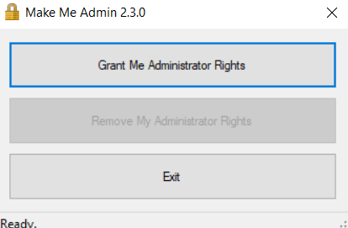
Proceed with the installation/uninstall of the application. Once finished, open Make Me Admin and choose “Remove My Admin Rights”. This will remove your admin access until the next time it is needed.
If you are trying to install an application and you have requested Admin access, and the application is still asking for admin rights, you will have to do the following. Once the installer has been downloaded to your computer, right-click on the installer and choose the option to “Run as Administrator”. This specifically escalates your privileges from the root level of the installer. Once the app is installed, you can remove your admin rights.
