How to Repair Global Protect VPN – Windows
Please note that you will have to have admin access to run this.

To repair the VPN, open your list of installed programs.
Go to Add and Remove Programs. Scroll down the list to Global Protect and click on the three dots on the right side of the screen.

Choose Modify.

The prompt will give you the option to remove Global Protect or Repair Global Protect. Choose Repair and click Finish
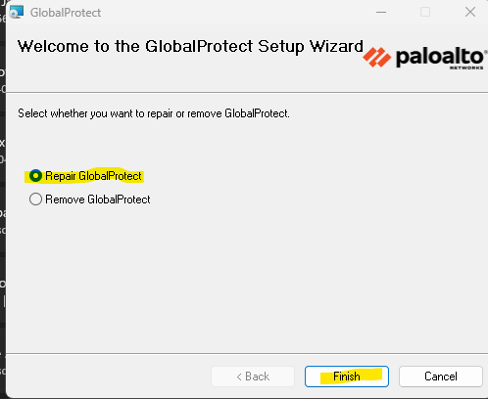

Global Protect will run through the repair, and you will see the following when completed.
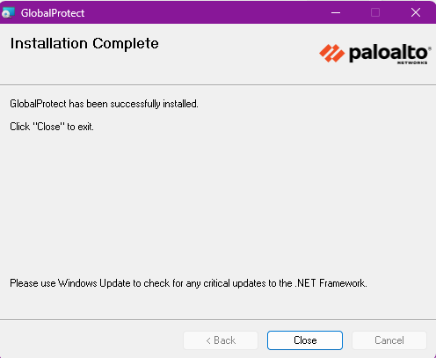
Click Close and retry your VPN connection.

