Add your WSU Email Account on the Android Outlook App:
The first time you open the Outlook app on your Android device, you will need to enter your WSU email address and sign in with your WSU Network ID and password on the WSU Network Authentication page. Successfully completing this initial login process will set up your WSU email account in the Outlook app.
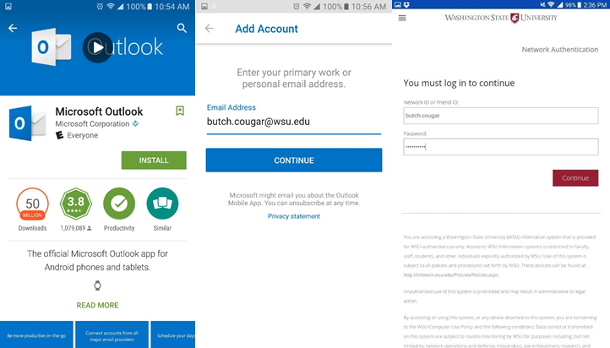Sign in page for WSU and Outlook

Complete multi-factor authentication (MFA) with your preferred security method. This security method can be the same authentication option you use when you access myWSU, Canvas, Workday, or other WSU services.
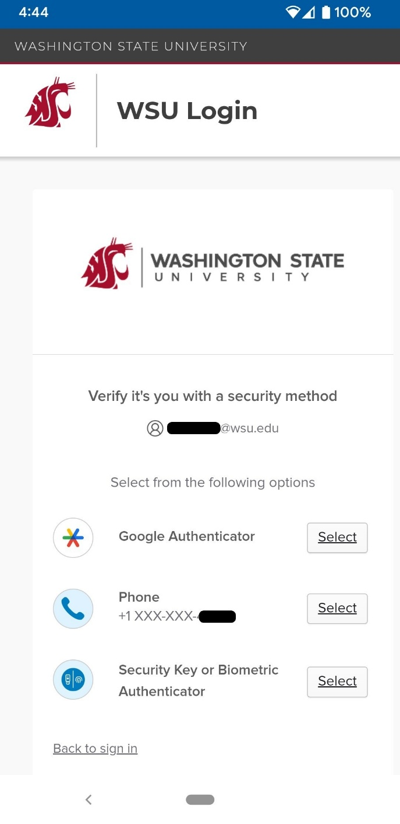MFA on Android Phone

Remove your WSU Email Account on the Android Outlook App:
- Open the Outlook app on your Android device.
- Select the Menu icon on the the upper left corner of your screen and tap Settings.
- Tap the email account you would like to remove or delete.
- A new window will appear. Tap Delete Account.
- A small menu will appear. Tap Delete.
- Quit the app completely and re-open to confirm that the email account was removed/deleted.

